User Guide Interbank Networks Application

Requirements

* Python 3.6 (available through Anaconda at the Bundesbank)
* Ideally Chrome for displaying the app (alternatively, Firefox also works)
* The application runs offline

Workflow

* On the command line, navigate to the location of the programme file ‘bank_network’
* Run python app.py
* In a browser window, navigate to the address provided on the command line
* Select all input files using the ‘browse’ button
* Press ‘submit’
* The name of all processed files will appear in the command window
* The initial network will appear
* Terminate the programme with ctrl+c

Specifications

Input files

1. General file format
   * Only csv files are recognised
   * Files follow the German format, i.e. using semicolons as delimiter and commas for decimal points
   * Quotation marks at the beginning and end of line are allowed and will be ignored
   * To check the file format, open the file in Notepad, which will show you the underlying format
   * Example

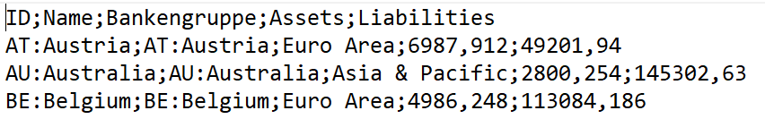

1. File names
   * The filenames need to contain ‘Matrix’ and ‘Bank’ and Year as well as a date in the format of yyyymm (e.g. ‘201609’)
   * File names can’t contain a space
   * Files names have to end in ‘.csv’
2. Edge files
   * Edges are specified in a matrix format, going from column to row ID
   * Column IDs have to be unique and can be alphanumeric
   * Row IDs are the same as the column IDs with an added ‘_’ in front (e.g. ‘_1’)
   * No duplicate uses of IDs in columns or rows are allowed
   * All matrix entries have to be numeric
   * The cell A1 needs to contain a term (e.g. ‘GeberNr’ or ‘ID’)
   * Example

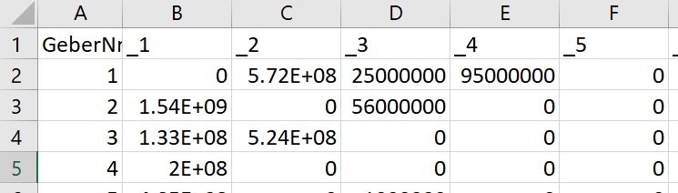

1. Node files
   * The first column has to contain unique IDs which correspond to those in the edge files. They can be alphanumeric
   * Any columns to the right of the ID column, which can be interpreted as numbers, will be interpreted as numbers and available as categories in the interface
   * A grouping can be provided in a column called ‘Bankengruppe’ (e.g. Kreditbanken, Sparkassen etc.)
   * Names diverging from IDs can be provided in a column called ‘Bankname’. Otherwise, the programme will default to the ID value
   * A custom color can be provided in a column called ‘Color’. Values can be color names (e.g. ‘blue’) or hex values (e.g. ‘#333’)
   * If no column contains numeric values, node size will default to 1
   * The column headers have to be the same for all node sheets
   * Example

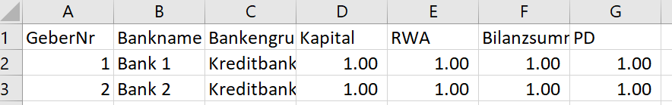

Interface

1. General
   * The network is zoomable and can be moved around on the canvas
   * It can be saved using the ‘Export PNG’ button, which will generate a filename reflecting the current network settings and appear in downloads
   * Alternatively right-clicking on the network allows for saving the image
2. Network
   * The network defaults to the most recent date, this can be changed per dropdown
   * The default structure is a single circle. Alternatively, a core-periphery structure can be chosen with one sector (Bankengruppe) at the centre. The dropdown becoming available once core-periphery is activated includes all categories supplied in the input files. The group at the centre will be the group with the highest average value for the selected category
   * As default, all sectors are shown. Alternatively, individual sectors can be selected per dropdown
3. Nodes
   * Labels: These are shown at the centre of the nodes if they have sufficient size. Labels can show the actual name provided, an anonymised value (‘Item 1’, ‘Item 2’ etc) or show nothing
   * Node size is per default set to 1 and can be scaled to all category values provided. The range of node sizes can be changed through the slider below the dropdown
   * Node color can be set to the default (coloring by sector), none (grey) or custom if a custom value has been provided in the input file
   * Nodes and their adjacent edges can be highlighted by clicking on them (ctrl+click allows highlighting several)
4. Edges
   * Edges with 0 value are hidden
   * Edges can be scaled to the absolute size provided for the current period or the change compared to last period. If the network shows the first period of input files provided, this setting will show no edges as no change can be calculated
   * The range in edge sizes can be affected through the slider
   * The ‘Edge cutoff’ slider allows one to select only the largest edges. It cuts off the percent of edges to the left of the selected point on the slider
   * Edges can be colored according to trend, with a decrease from last period showing in red, an increase in green and no information or no change in grey